Herb-Dominated Communities
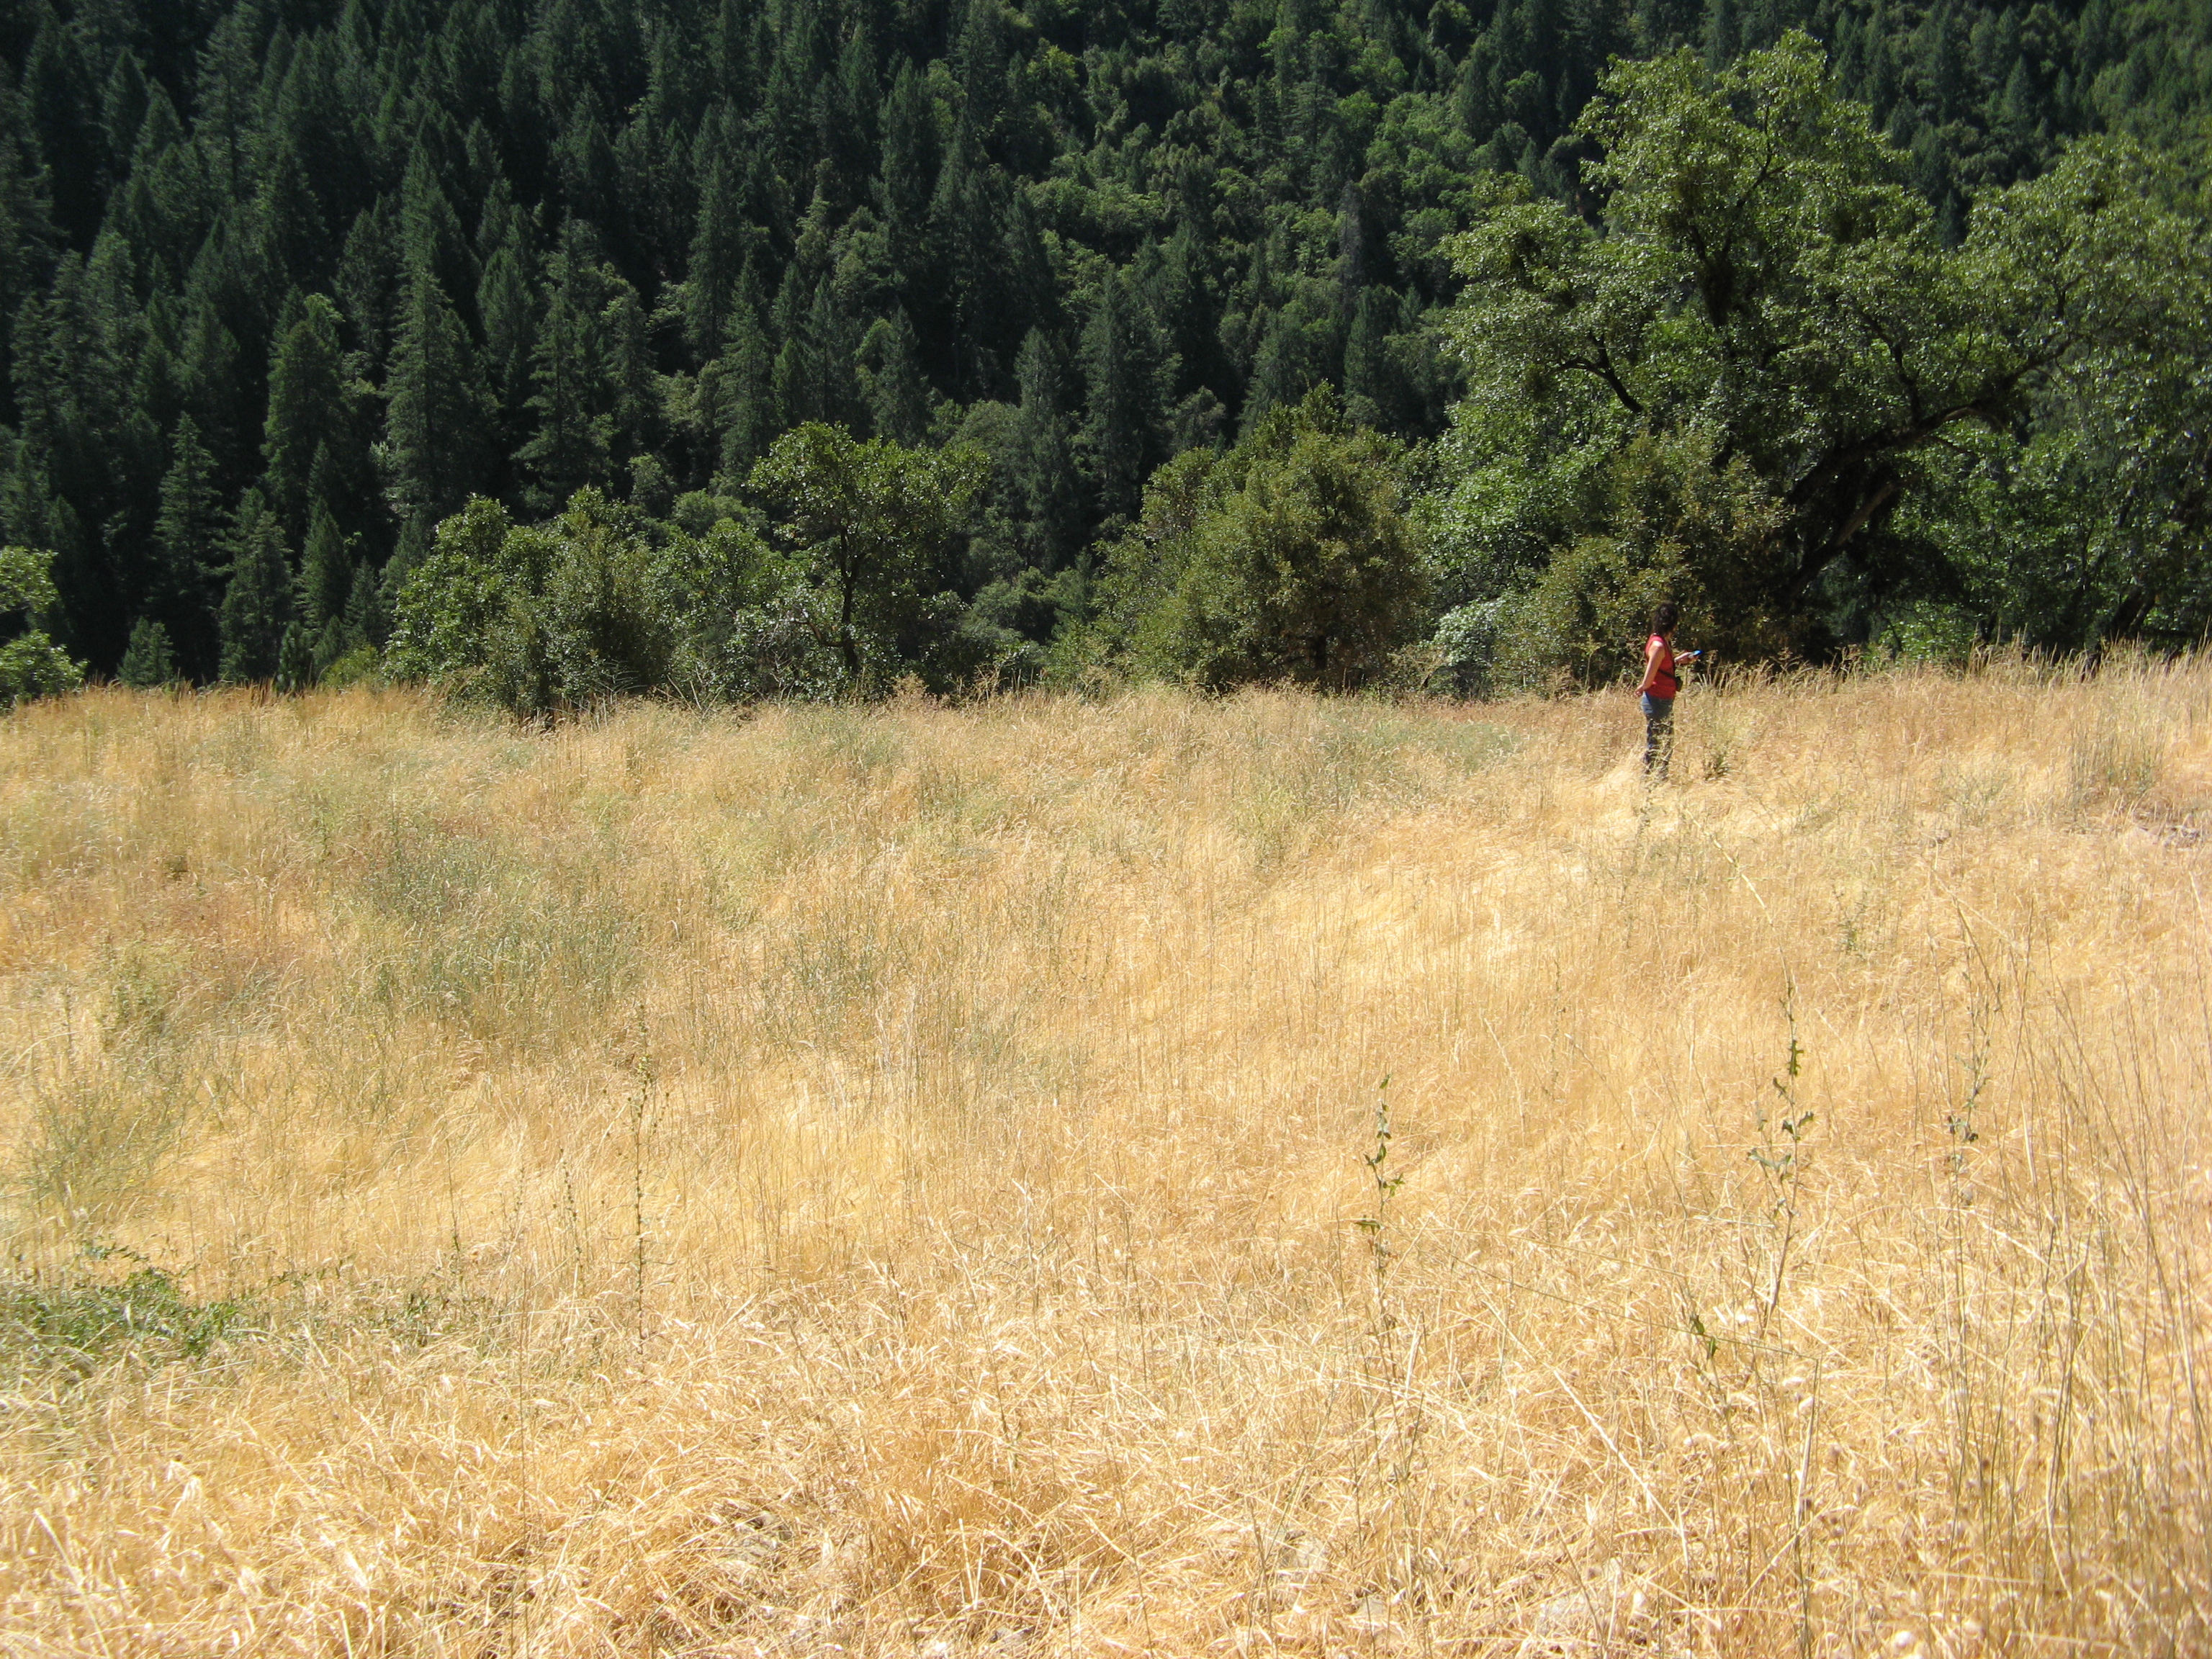
Annual Grasses / Forbs (HG) community located along the road from FR 69 to Middle Fork Interbay.

Shrub-Dominated Communities

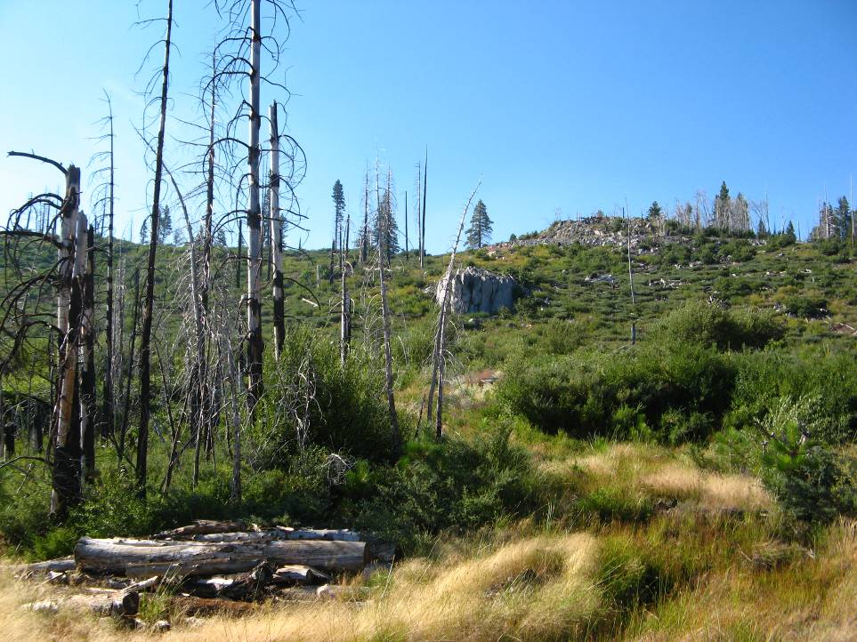
Upper Montane Mixed Chaparral (CX) communities located along FR 96 from Duncan Creek Diversion to French Meadows Reservoir. The burned trees are remnants of a Mixed Conifer–Pine (MP) community which was burned in the 2001 Star Fire.

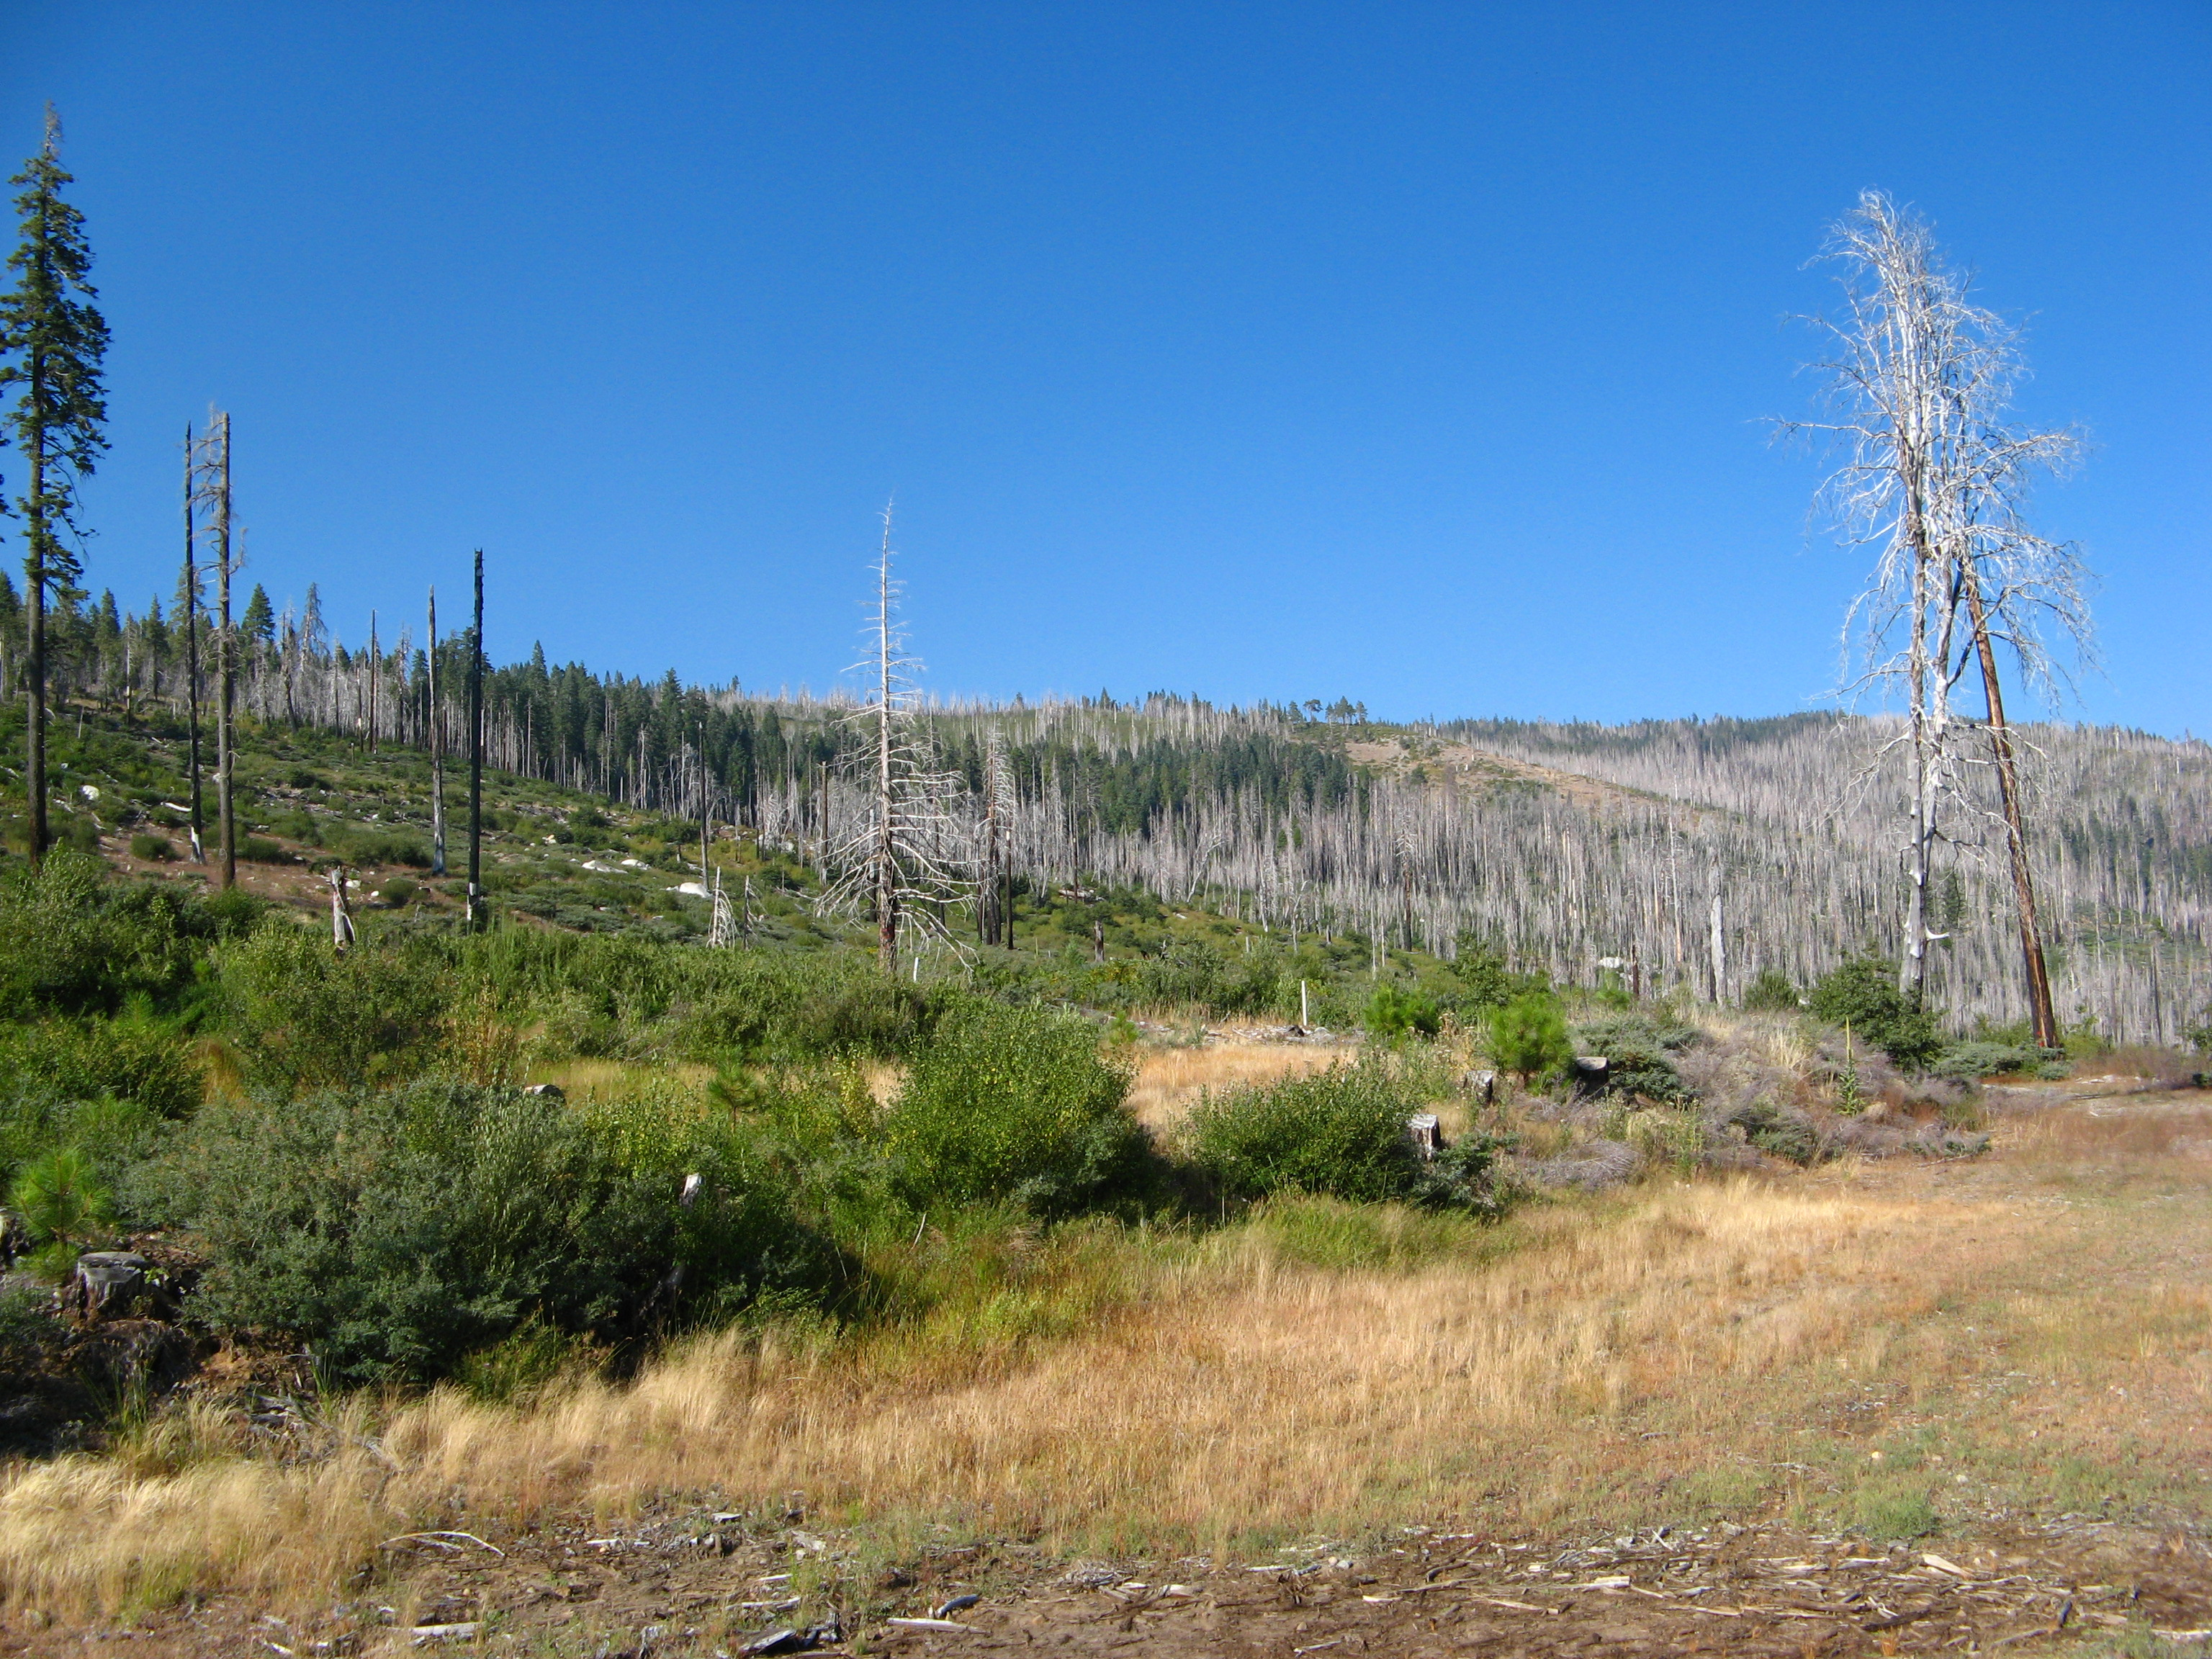
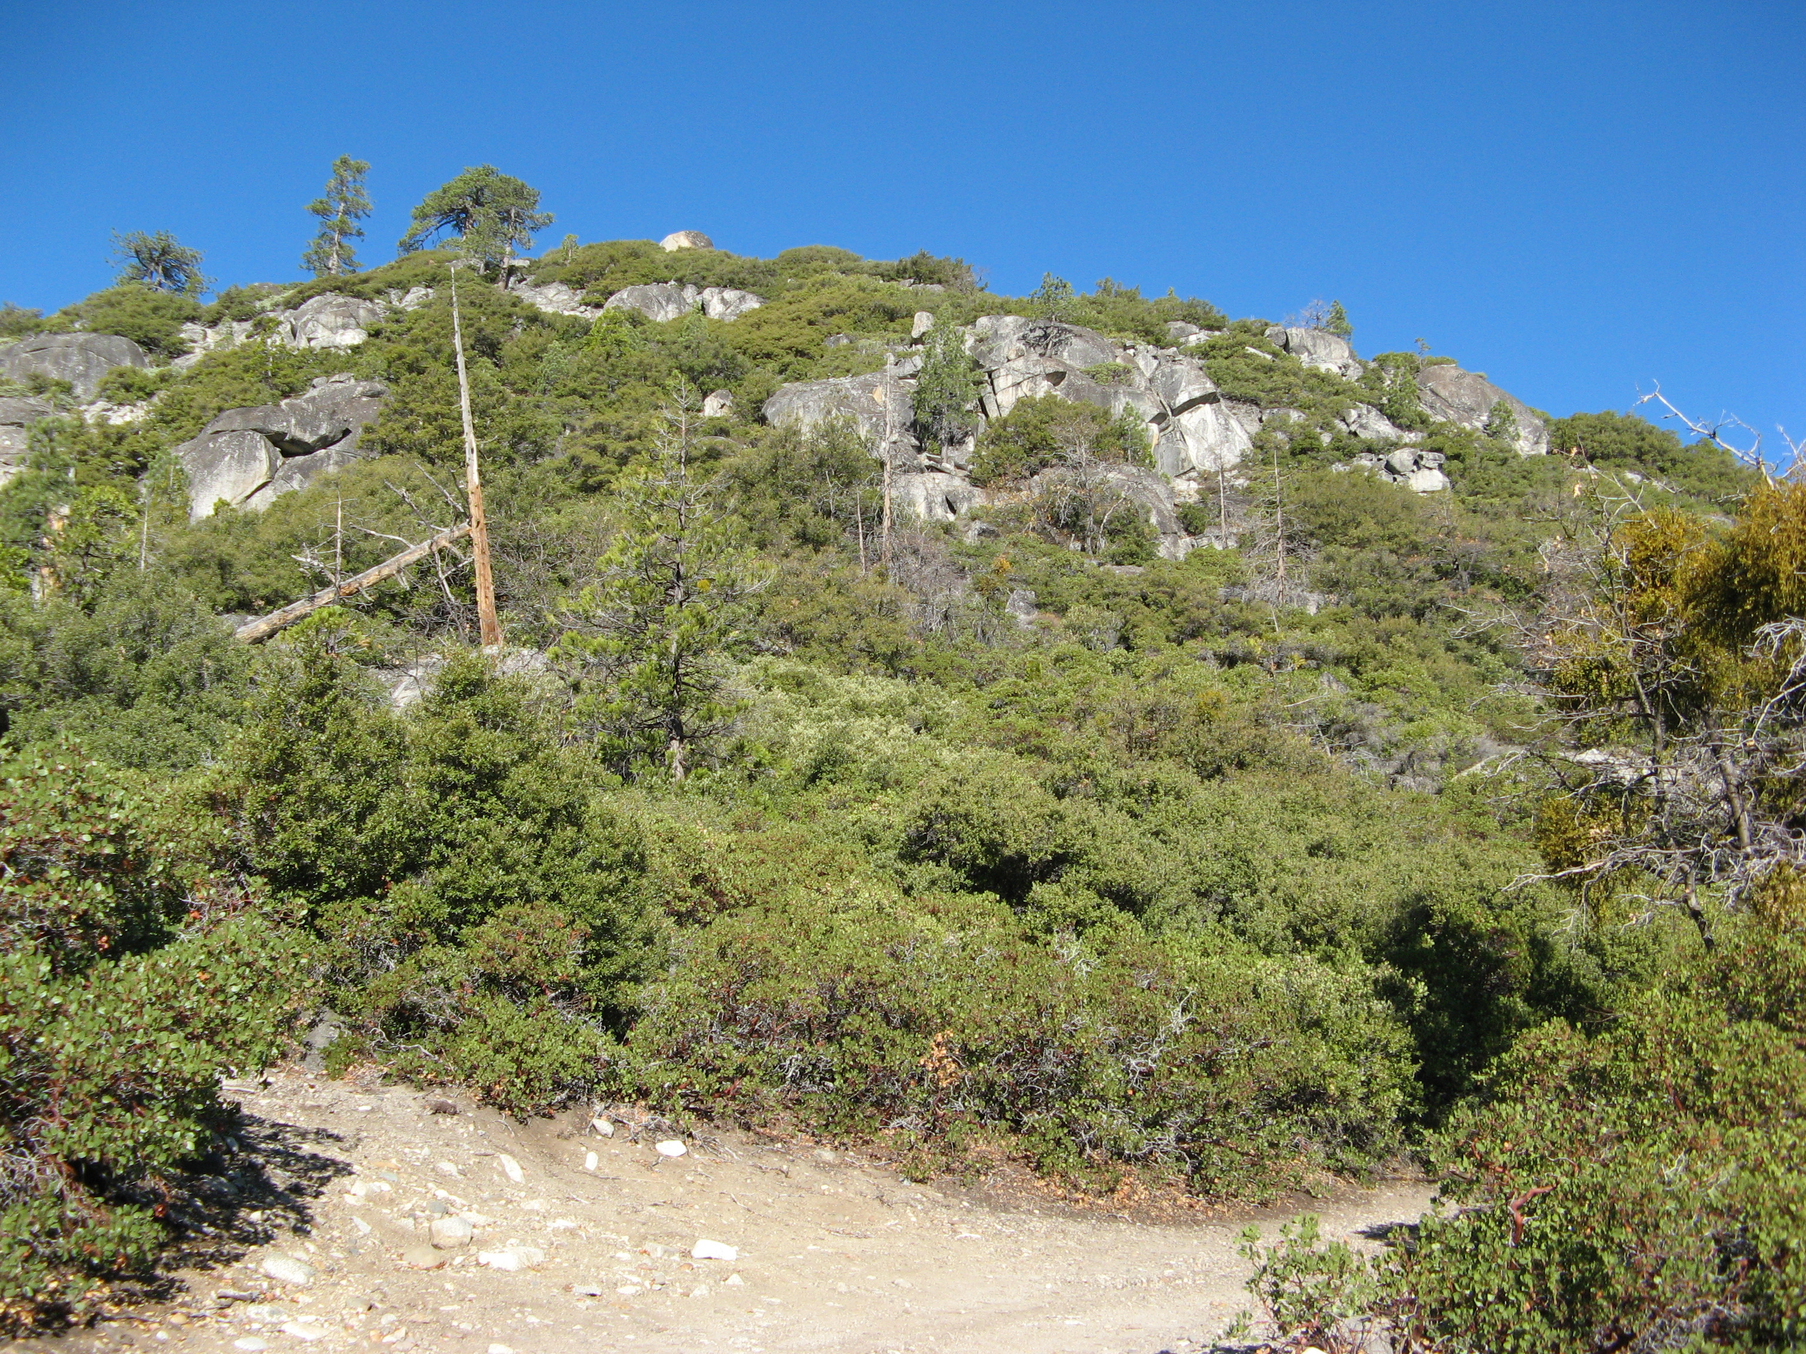
An Upper Montane Mixed Chaparral (CX) community located on the northern side of Hell Hole Reservoir in the vicinity of the proposed French Meadows – Hell Hole Tunnel Surge Shaft Tank Construction Staging Area.

Tree-Dominated Communities

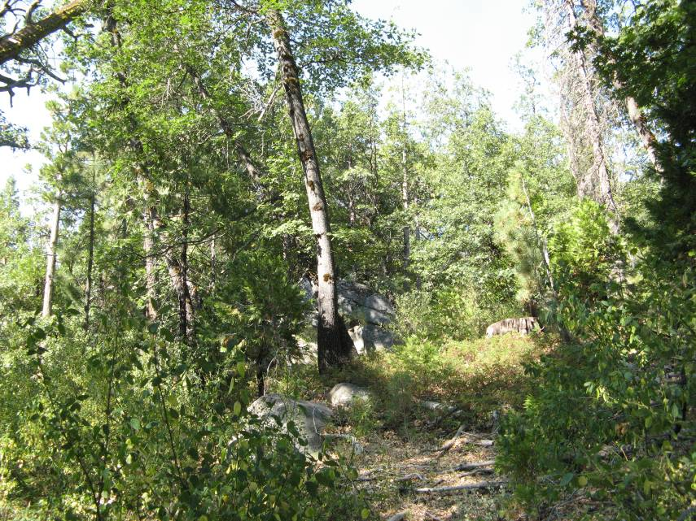
Both photographs on this page show Black Oak (QK) communities located along FR 14NO9A, on the northern side of Hell Hole Reservoir.

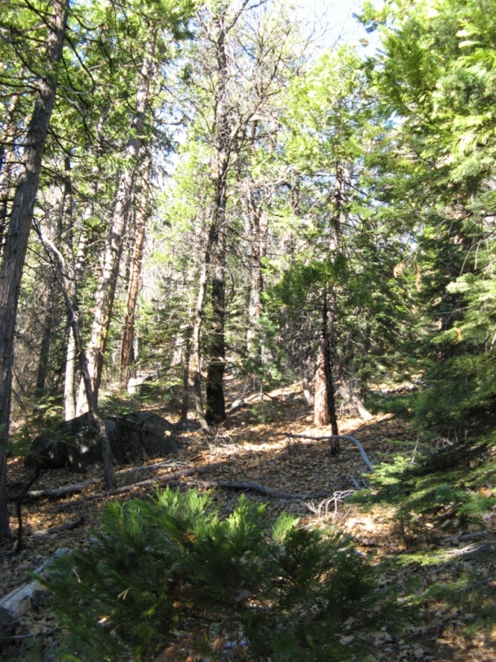
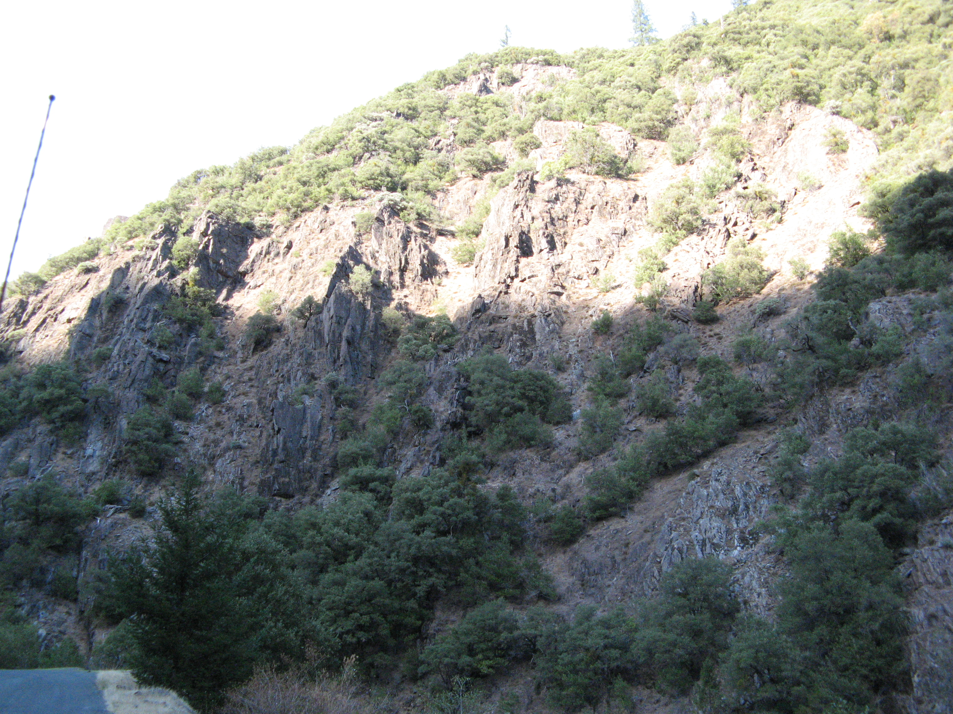
Canyon Live Oak (QC) on the steep, inaccessible slopes near Middle Fork –Interbay Dam.

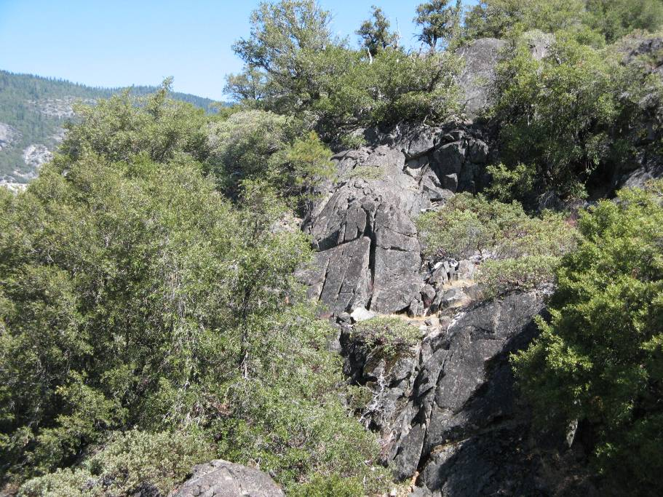
A Canyon Live Oak (QC) community on the south side of Hell Hole Reservoir near Hell Hole Dam.

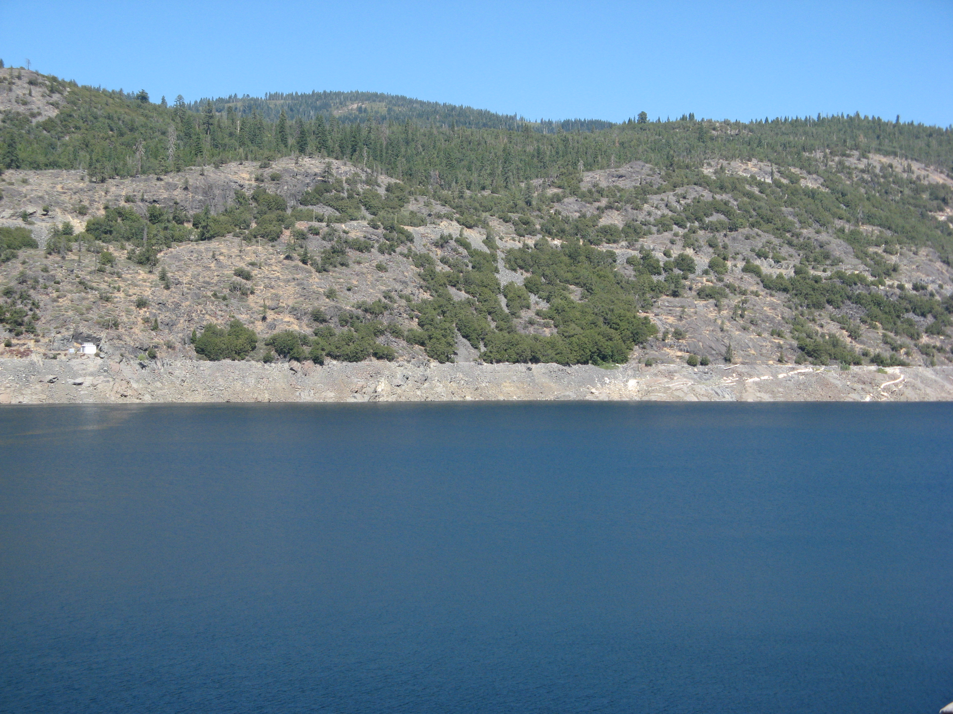
A view of a Canyon Live Oak (QC) community on steep granite slopes near the Hell Hole–Middle Fork Tunnel Gate House (visible to the left). Mixed Conifer–Pine (MP) communities are visible near the top of the ridge.

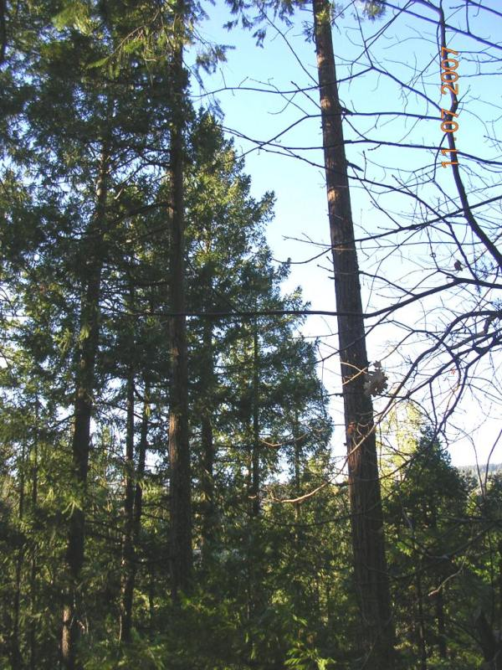
A Douglas-Fir–Pine (DP) community located on the south side of Hell Hole Reservoir

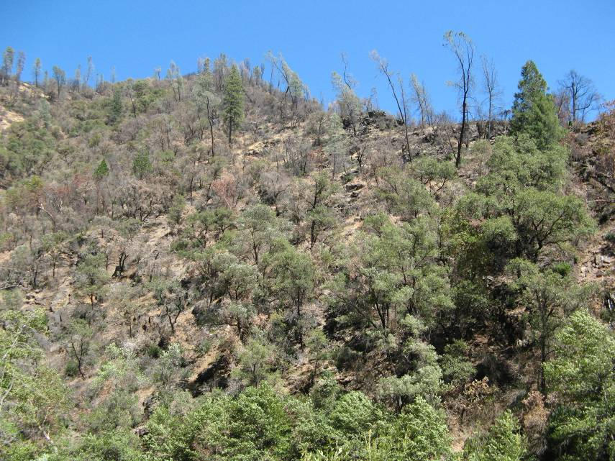
A Gray Pine (PD) community along the ridgeline above from Ralston Picnic Area. This area was affected by the 2006 Ralston Fire.

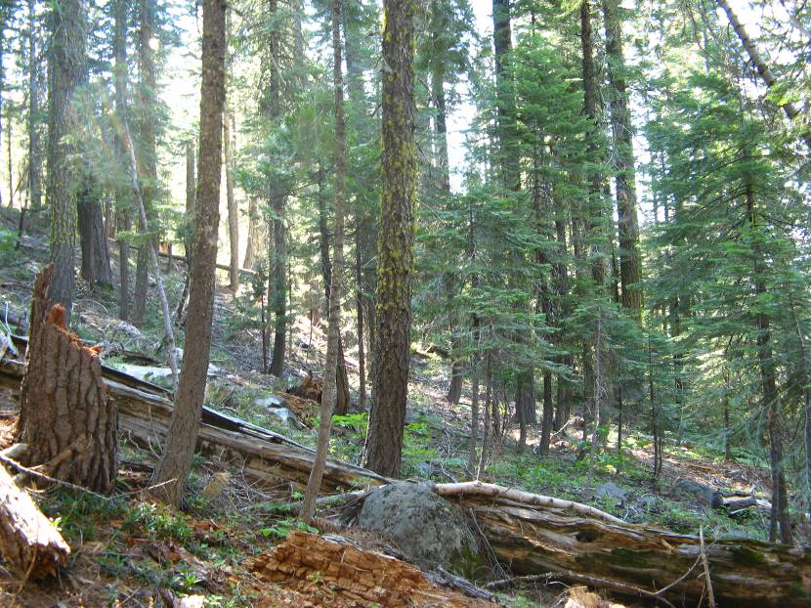
A Mixed Conifer–Fir (MF) community located on the south side of French Meadows Reservoir near the French Meadows – Hell Hole Tunnel Intake Trash Rack.

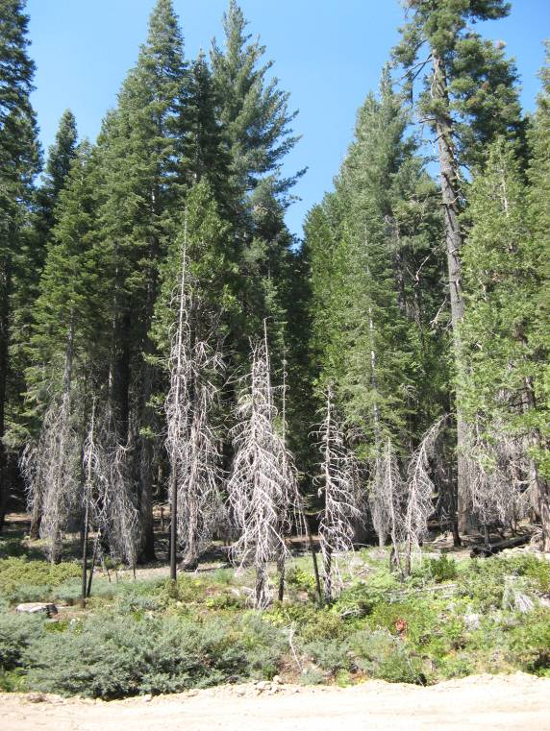
A Mixed Conifer–Pine (MP) community located on the north side of Duncan Creek Diversion. Trees burned trees in the 2001 Star Fire can be seen in the foreground.

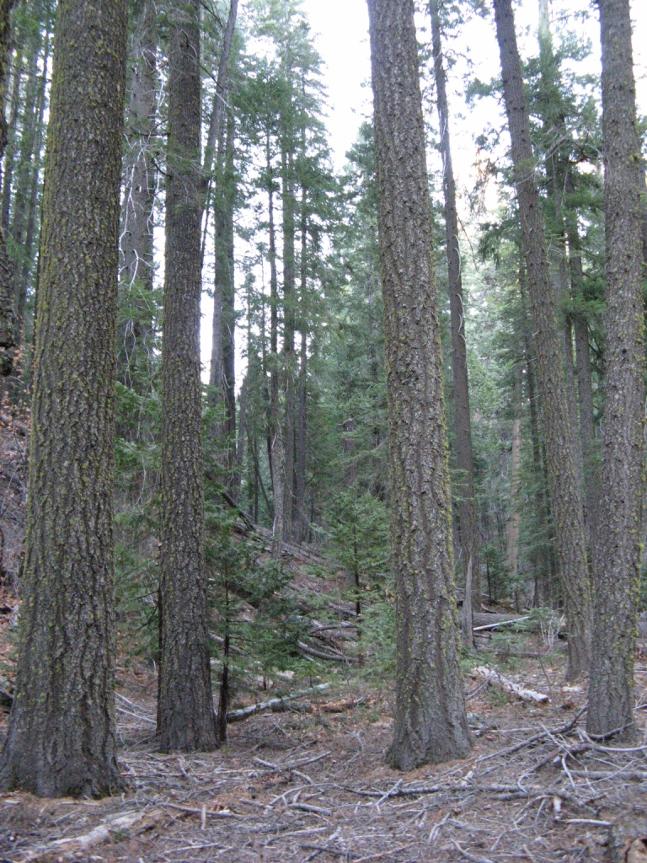
A Mixed Conifer–Pine (MP) community near North Fork Long Canyon Diversion.

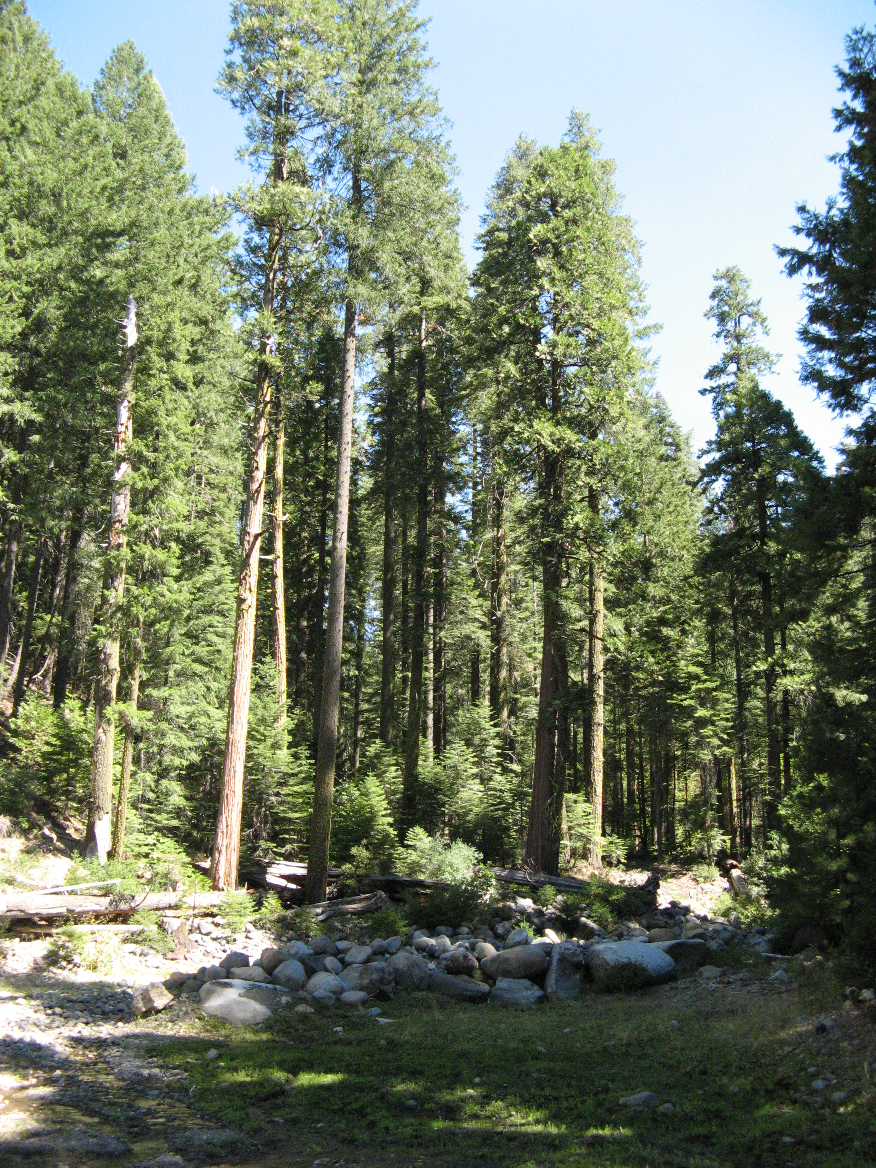
A Mixed Conifer–Pine (MP) community near South Fork Long Canyon Diversion.

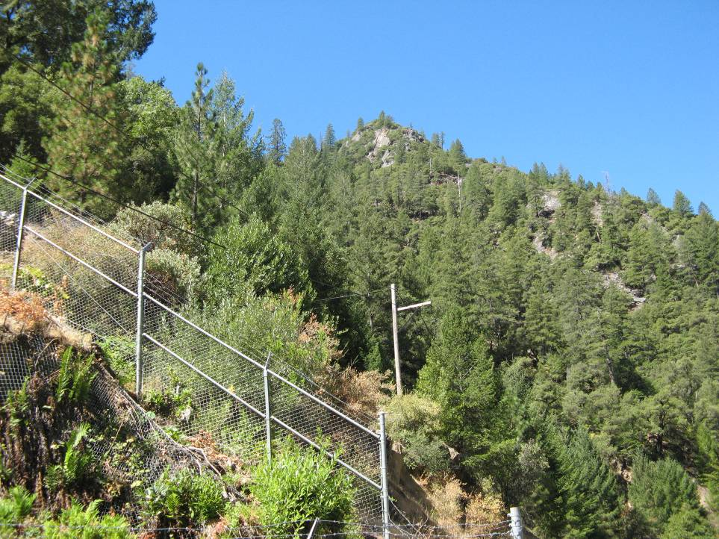
A view of a Pacific Douglas-Fir (DF) community, looking west from the Upper and Lower Switchyards at Middle Fork Interbay.

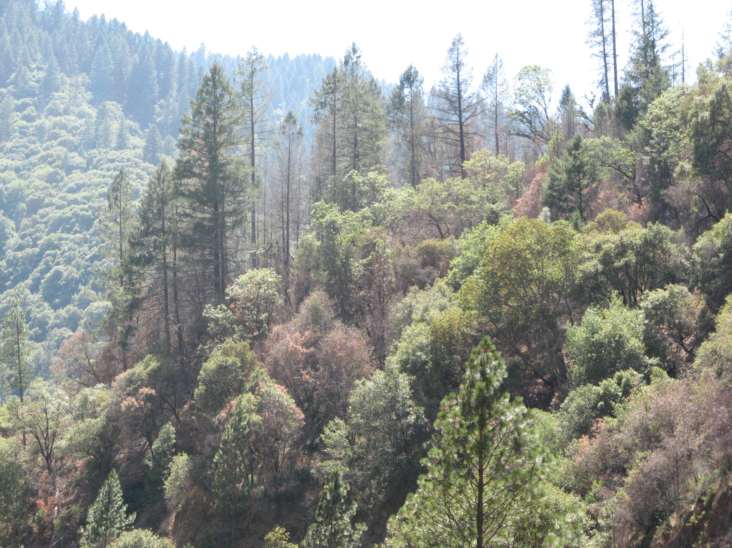
A view of the steep canyon slopes leading to the Ralston Afterbay. The vegetation communities, which vary with slope and aspect, include Pacific Douglas-Fir (DF) and Canyon Live Oak (QC).

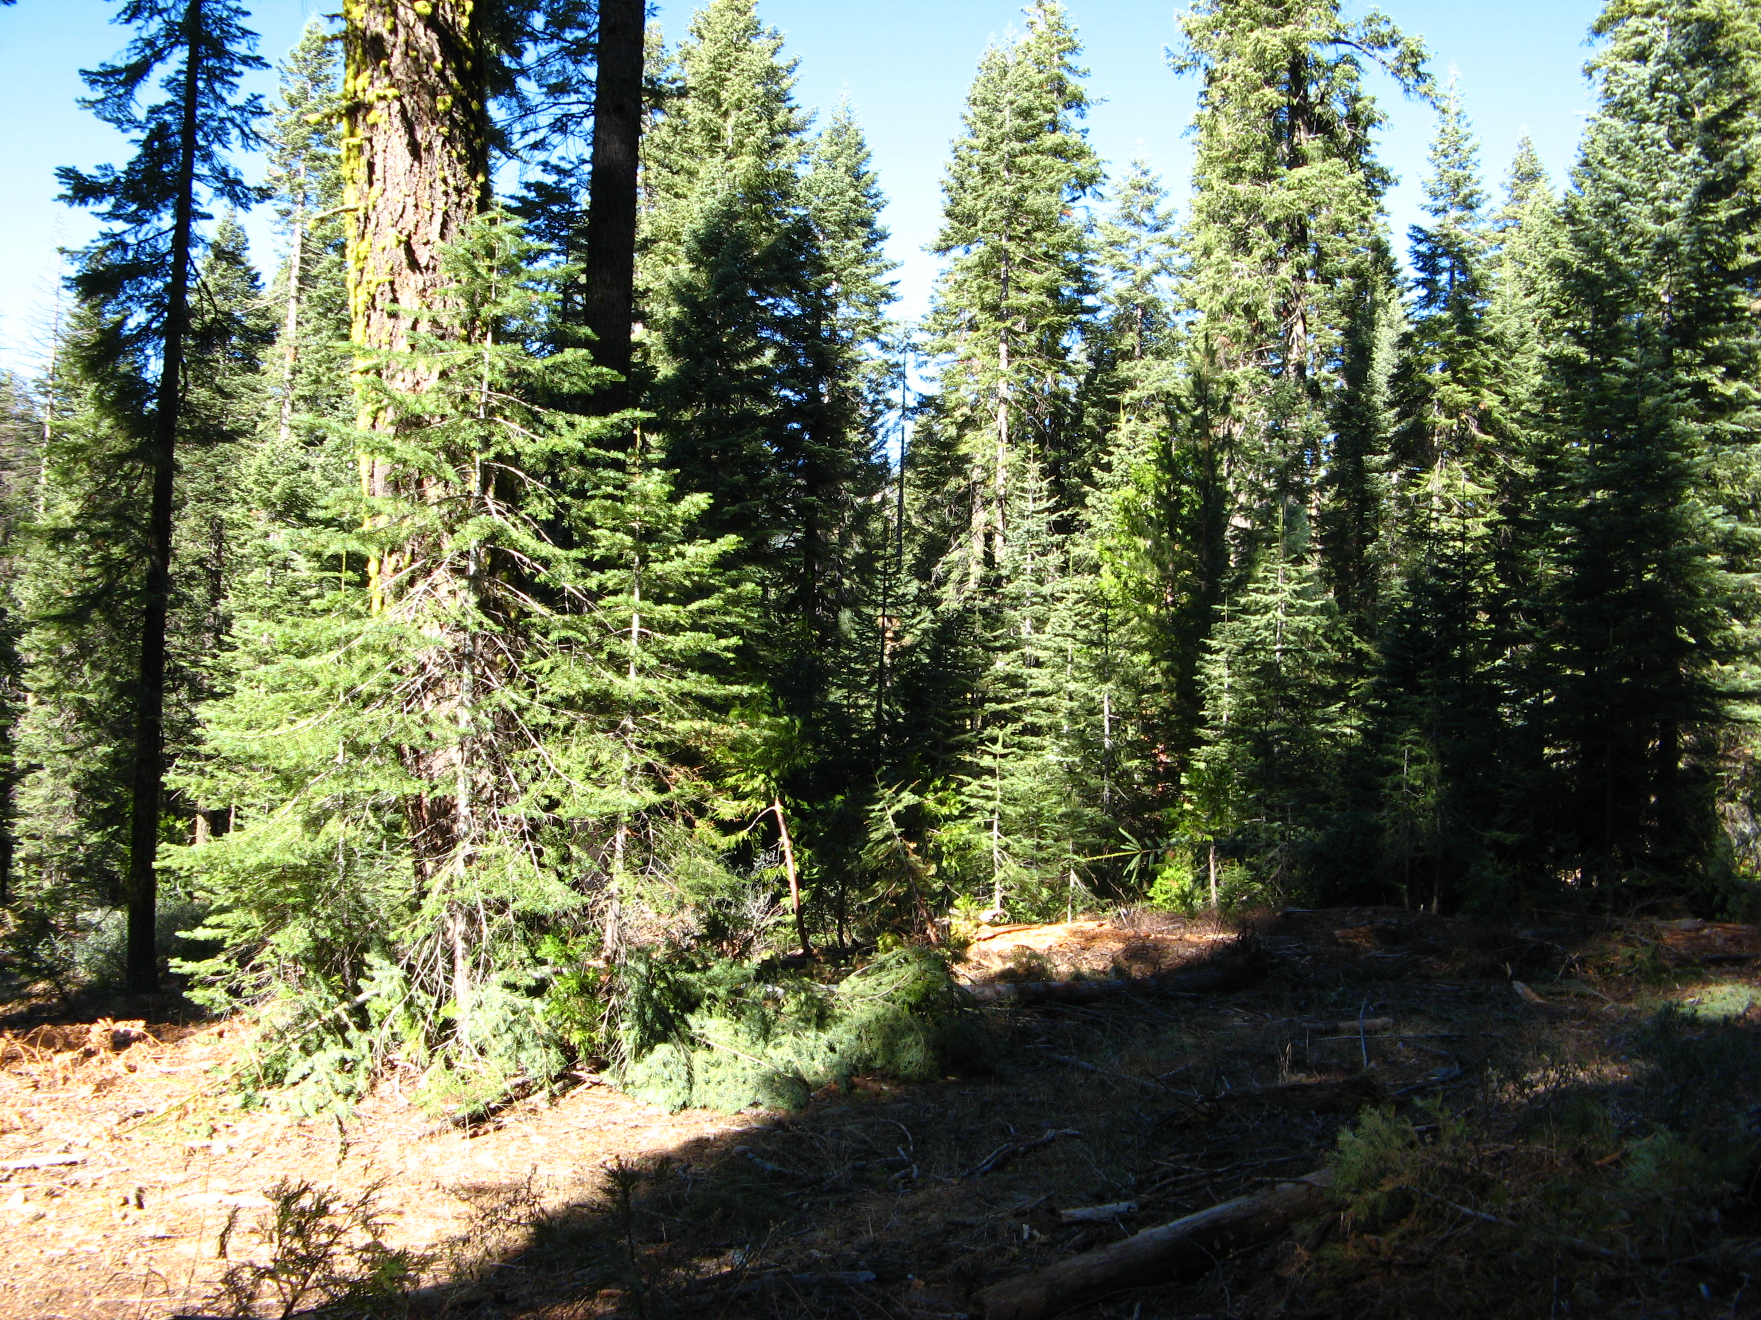
A White Fir (WF) community in located at the eastern end of French Meadows reservoir.

